# VARpedia – user manual

By Group 48  
GitHub Repository: <https://github.com/kcho9906/SOFTENG206_a04>

Table of Contents

VARpedia – user manual 1

First Time launch 2

# First Time launch

Thank you for choosing VARpedia as your choice of language learning tool. Before you launch, please be aware that this is only compatible with Unix/Linux operating systems and also requires the flickr4java API to function correctly.

Furthermore, you will need to have the bash commands, espeak, ffmpeg, ffplay, ffprobe, mp3info, and lame to run this application correctly.

# Main menu

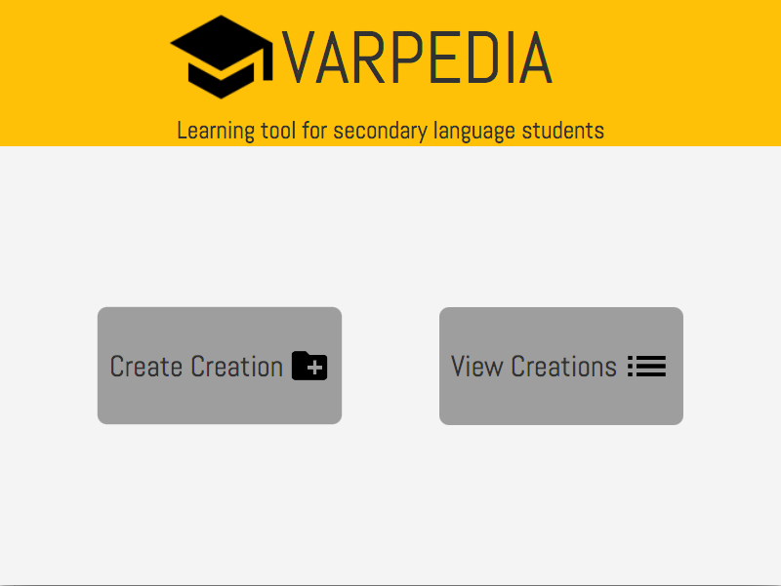

Figure 1 : Main Menu Scene

On opening of the application (VARpedia), you will see the Main Menu. From the Main Menu you can either create a creation or view existing creations by clicking on the respective buttons.

|  |  |
| --- | --- |
| To create a creation | To view a creation |
| Figure 1.1: Create a creation button | Figure 1.2: View creations button |

# Create a creation

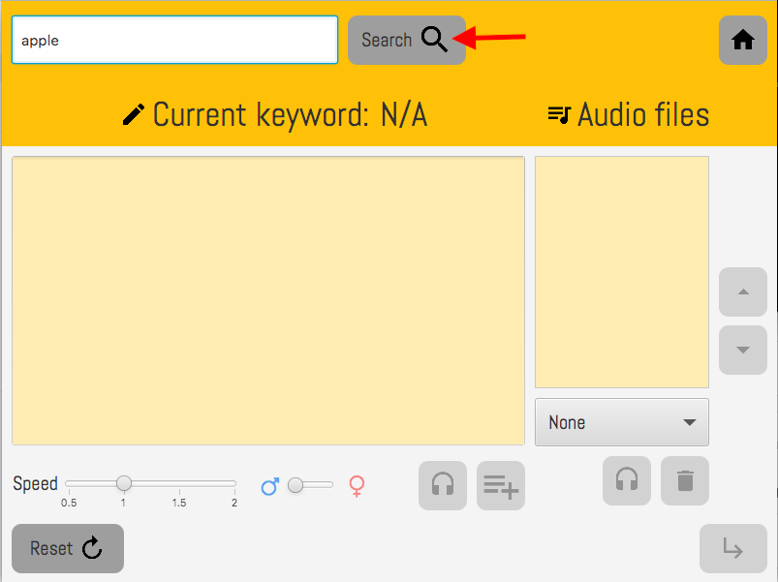

Figure 2: Create a creation scene

Changing to the create a creation scene, the user can enter in an English word into the search bar at the top. Once they have the term they want, they can push the search button. The search button will find information of the topic and show the result in the text area below.

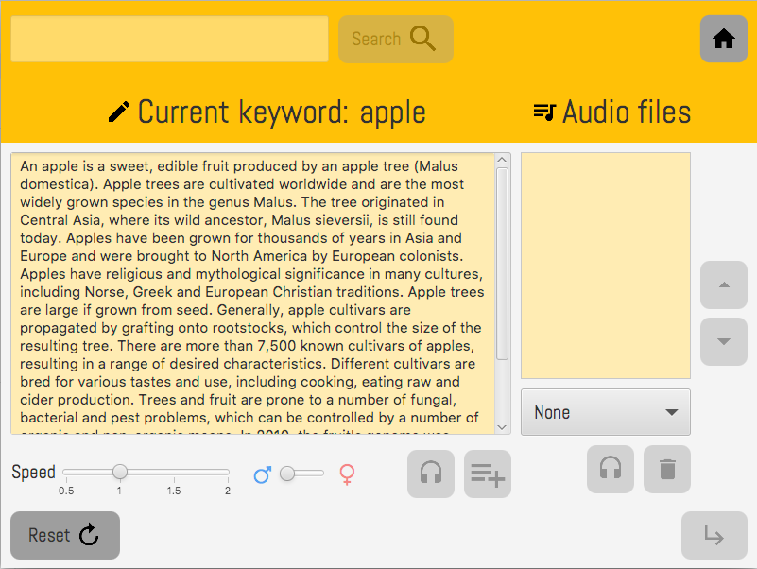

Figure 2.1: Text output

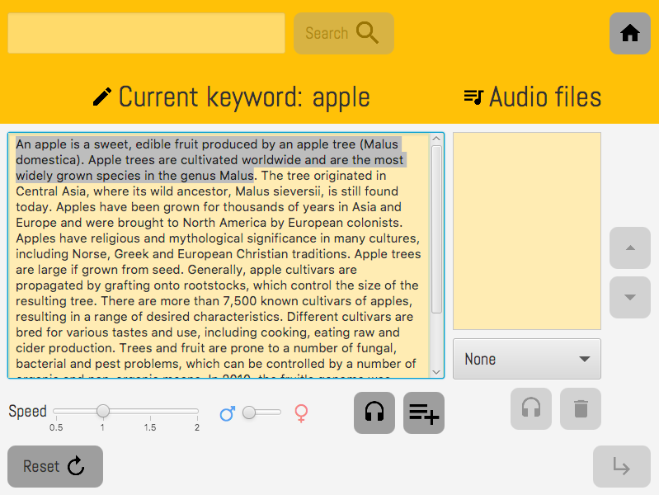

Figure 2.2: Highlighted text

After selecting a chunk of text (below 30 words), the user can adjust the speed and change the type of speaker between male and female. Once settings have been changed, the user can choose to preview the text, or save the audio file.

|  |  |
| --- | --- |
| Figure 2.3: eSpeak speech modifiers (speed and gender) | |
| Figure 2.4 Preview Audio Button | Figure 2.5: Add Audio to List Button |

